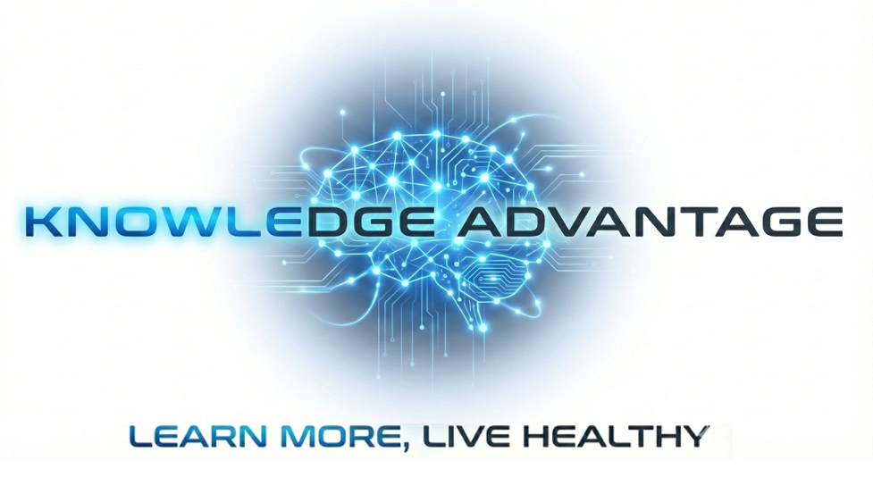

Domain: Chronic disease prevention and care.
Focus: Patient, caregiver and family education
The Problem with Patient Education:
Studies show patients receiving comprehensive education have shorter hospital stays, better pain management, and higher satisfaction than those without education Engagedmd. One recent study found patient revisit rates dropped from 53% to 41% after implementing an educational intervention PubMed Central. Low health literacy costs the U.S. healthcare system substantially, with health costs four times higher for those with low literacy, plus 6% more hospital visits and hospital stays averaging two days longer Globo.
But there are challenges:
- Adoption is low - Less than 50% of patients register to use patient portals, and routine usage is even lower Oxford Academic, despite these being key educational delivery channels.
- Implementation barriers - Healthcare providers face time constraints during consultations that hamper their ability to offer in-depth, personalized education PubMed Central. Nurses cite lack of resources, inadequate time, insufficient knowledge and skills, and lack of patient readiness as major barriers ResearchGate.
- Equity gaps - Approximately 93 million American adults have low health literacy, with only 12% considered proficient Globo. Some patients are "hardly reached" by education programs due to lower educational levels, severe co-morbidity, low health literacy, and sociocultural problems NCBI.
- Inconsistent quality - Most patient education materials aren't written for the average American reading level of 7th-8th grade MicroMD.

The Bottom Line
Patient education should work and can work when properly implemented. But there's a large gap between the controlled studies showing benefits and real-world implementation where time pressures, literacy mismatches, limited adoption, and resource constraints undermine effectiveness. The promise is there, but many healthcare systems haven't yet figured out how to deliver it reliably at scale.
Patients, caregivers and family are relying on Google for their medical care advice. This compounds the problem of being poorly informed when faced with heath challenges. In the extreme, confusion leads to desperation and then anger as patients feel abandoned and malpractice accusations rise.
The problem, we are ‘educating’ people not encouraging ‘individual learning’. Education is designed to be efficient. Learning is a personal responsibility, a commitment to ‘critical thinking and the relentless pursuit of the truth.
Knowledge Advantage is developing a Critical-Learning Platform for patients , caregivers and families to learn about chronic diseases, We are starting with dementia.
In our view, a Critica- Learning Platform supports visual, interactive, adaptive learning. It is personalized and available Ad-hoc (in the. Moment).
Answers to medical care questions should be simple to obtain and understandable.mAnswers are the source of more questions, many of which are predictable. A Critical-Learning Platform leverages AI technologies to personalize an interactive and adaptive learning experience. that begins with knowledge visualization.
